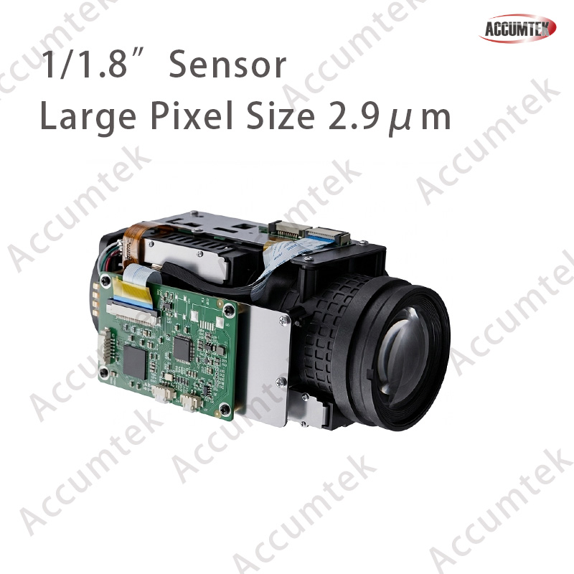

35x camera core module – Parameters

Features

Category | Item | Description
General Parameters | Main Chip | Hi3516DV500, ARM Cortex A55@850MHz dual-core
General Parameters | DDR (Memory) | 8 Gbit LP DDR4
General Parameters | Flash | 1 Gb (2 Gb optional for bulk orders)
General Parameters | Image Sensor | 4MP 1/1.8" IMX664 low-illumination CMOS sensor Color: 0.0001 Lux@F1.0 B/W: 0.0001 Lux@F1.0
General Parameters | Watchdog | Hardware watchdog
General Parameters | WDR | 120 dB
Image Parameters | Main Stream | 30 fps@ (2688×1520, 2560×1440, 1920×1080)
Image Parameters | Sub Stream | 30 fps@ (704×576, 640×480)
Image Parameters | Third Stream | 30 fps@ (704×576, 640×480)
Image Parameters | Video Compression | H.265+ / H.265 / H.264
Image Parameters | Bitrate | 512 Kbps ~ 32 Mbps
Image Parameters | White Balance | Auto / Manual / One-Push
Image Parameters | Shutter | 1/12 s to 1/100,000 s
Image Parameters | Noise Reduction | 3D / 2D noise reduction
Image Parameters | WDR (Digital) | Digital WDR supported
Image Parameters | Auto Iris | DC IRIS auto iris supported
Image Parameters | AISP | AISP image enhancement supported
Image Parameters | Image Functions | Backlight compensation, highlight suppression, defog, anti-flicker, lens correction, mirror, flip, gain, etc.
Audio | Audio Interface | 1-ch input (mic/pickup); 1-ch output (headphone/amplifier)
Audio | Audio Compression | G.711U / G.711A / AAC-LC
Network Connection | Simultaneous Preview | Up to 12 channels
Network Connection | Network Protocols | CGI, HTTP, HTTPS, GB28181, SIP, RTMP, TCP/IP, UDP, RTP, FTP, RTCP, RTSP, NTP, DHCP, DNS, DDNS, SNMP, SSL/TLS, WebSocket; ONVIF compliant
Network Connection | Browser | Plugin preview: IE10, IE11 Plugin-free preview: Edge, Chrome, Firefox
Auxiliary Interfaces | Network | 1× RJ45 10M/100M Ethernet port
Auxiliary Interfaces | Audio | 1-ch input (mic/pickup); 1-ch output (headphone/amplifier)
Auxiliary Interfaces | Light Board Ctrl | Light sensor detection input, PWM dimming supported
Auxiliary Interfaces | USB Interface | 1× USB 2.0 (5 V power); supports 4G / WiFi (dual-band) / storage / UVC expansion
Extension | Analog video | HD LVDS, CVBS for extension
General Parameters | Dimensions | 50× 50 × 100 mm
General Parameters | Weight | 100g
General Parameters | Operating Temp. | -20°C ~ +60°C
General Parameters | Power | DC 12 V input, 4 W power consumption
Lens & Model | Series | 4mm fixed Lens/F1.0
Lens & Model | Series | 10x Optical Zoom Lens
Lens & Model | Series | 25x Optical Zoom Lens
Lens & Model | Series | 35x Optical Zoom Lens

